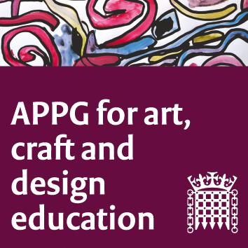
All-Party Parliamentary Group for Art, Craft and Design in Education

Tuesday 24th November 5-7 pm

Katie Leonard Programme Leader PGCE Secondary Art, Craft and Design

I would like to thank Susan Coles and our Chair Sharon Hodgson MP for the focus of this APPG to be on Initial Teacher Education (ITE), and to NSEAD president Dr Rachel Payne, with the response Letter to Mr Gibb and to thank also those courageous artists, makers and designers who decide to take up the vocation of teaching.

The ITT census data shows that in 2019-20 that collectively we only recruited 69% of trainees and in 2018-19 73% of the trainees. needed. We have not been improving on recruitment. This data shows that we are ranked very poorly compared to the target recruitment of teachers of many other subjects. So, yes, we need more Art teachers not less.
Application numbers have sharply inclined this year due to the bursary, but in my experience, the quality and seriousness of those applicants have also risen. Those that do apply have made sure they want to do this, have already tested their passion and commitment for the subject.

My role as Programme Leader of a PGCE in Secondary Art, Craft and Design at Staffordshire University is part subject leader, broker of partnerships, counsellor and guidance tutor, trouble-shooter, academic and assessor.

It is an appropriately complex role to reflect the learning journeys of my students. In just 36 weeks, with over 15 of those in teaching practice in three schools with experience of planning, teaching and assessing across three key stages.

This is coupled with a programme designed to extend subject expertise, address personal skills and knowledge gaps but also introduce reflection, theory and research to them.

All our subject mentors talk about the impact our students have on pupils and indeed themselves as practitioners – new ideas, refreshing perspectives, and passionate dedication developing relationships with young learners.

I have the pleasure of introducing you to Lee and Lucy, brave representatives from this year’s PGCE art cohort at Staffordshire University.

When planning together what we wanted to share with you, we decided to speak from the heart and without soundbites, statistics or a so-called evidence base.

Lee and Lucy want to try to give you an insight into why they made the decision to become art and design teachers, how they feel about it now in the middle of their training and their aspiration for the future of their own profession and those who are considering teaching art and design in the future.

