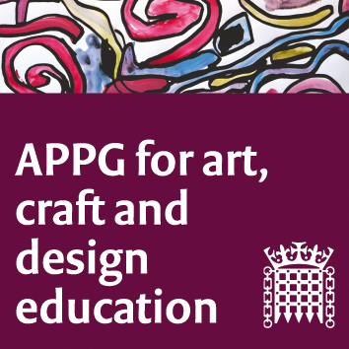

The All-Party Parliamentary Group for Art, Craft and Design in Education

An informal meeting (online) Tuesday June 2nd 2-4 pm

Agenda

Meeting focus/theme: Discussion and sharing of how teaching and learning has needed to change rapidly due to Coronavirus. We will also look at APPG plans for the near and distant future, and a hold a discussion on the vision for the direction of the APPG, post-pandemic.
- Welcome. Sharon Hodgson MP
- Zoom protocol reminders. Susan Coles, NSEAD
- Summary of NSEAD's activities since 'lockdown' and plans for Conference etc. Michele Gregson, Sophie Leach, general Secretary and assistant General Secretary NSEAD
- Examination changes 2020, a summary from Liz MacFarlane, President elect, NSEAD
- The teacher’s point of view: what lockdown has meant for them in primary, secondary and tertiary phases of education. Ruth Robinson Lead Teacher and Leader of Learning: Arts, English & Business at Durham 6th Form , Jessica Austin Burdett, Head of Art, Design and Technology at a secondary school in London, and a primary teacher (no name yet)
- Wellbeing issues, young people and art educators, around Covid 19. The NSEAD Special Interest Group, led by Marlene Wylie Vice President
- Group discussion chaired by Sharon Hodgson. The future focus and work of the APPG, based on previous discussions held at the AGM in 2020, and the previous meeting in February. Suggestions summed up and shared. Jack Mayorcas and Susan Coles will sum up previous discussions
- Next meeting- time and date and platform
- AOB

