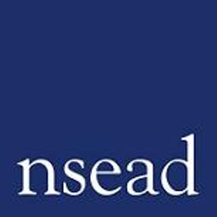
NSEAD Continuing Professional Development for Art, craft and design teachers
Request form
Name of teacher requesting CPD | (teacher to complete)
Title of the Course: | Mind the Art Gap: Leading your professional practice
Course Tutors: | Michele Gregson, Sean Taylor
Focus of this course: | Professional behaviours standard and what that means for Art and Design specialists. Practical advice and guidance and strategies exploring the expectations, how to manage them, and knowing your rights in the workplace.
What will delegates learn? | Professional development and reflective practice – priorities and opportunities for art educators  Professional relationships – how to work effectively with other adults  Wider school culture - how to take a lead in supporting whole school priorities  Workload and well-being – how to give your all, and still love your job
How will this develop professional practice for specialist art craft and design teachers? | Art, craft and design specific Information, advice and guidance to support Early Career Framework Professional behaviours (Standard 8 – Fulfil wider professional responsibilities)  https://assets.publishing.service.gov.uk/government/uploads/system/uploads/attachment_data/file/978358/Early-Career_Framework_April_2021.pdf

For teachers to complete
How will my students benefit? | Teacher reflective practice and continuing devleopment will support student learning in Art, craft and design
How will my learning contribute to whole school improvement priorities? | Teacher personal development, leadership and management, improving staff’s subject, pedagogical and pedagogical content knowledge; community engagement, workload and well-being, equity, diversion and inclusion,
Links to performance review and personal development goals | Links to: https://assets.publishing.service.gov.uk/government/uploads/system/uploads/attachment_data/file/978358/Early-Career_Framework_April_2021.pdf
Cost | NSEAD member: Free  Non member: £75

