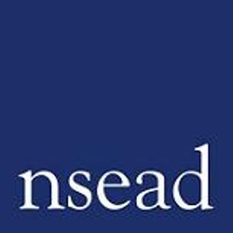
All members are invited to attend a meeting to ratify decisions taken at the 133rd ^{Annual} General Meeting of the National Society for Education in Art and Design, which was held on Saturday the 25th of September 2021 at 11am.
All members are invited to attend this brief meeting on the 13 October at 5.45pm to be held by Zoom. This session is a continuation of the AGM held on the 25th of September.
Twenty five members present and in good standing shall form a quorum to ratify and conclude the business of the AGM.
Agenda
13/21 TO RECORD ATTENDANCE AND TO RECEIVE APOLOGIES FOR ABSENCE
14/21 TO RATIFY THE MOTION CARRIED ON 25TH SEPTEMBER TO APPROVE THE GENERAL SECRETARY’S REPORT FOR 2019-20
15/21 TO RATIFY THE MOTION CARRIED ON 25TH SEPTEMBER TO APPROVE THE HONORARY TREASURER’S REPORT FOR 2019-20
16/21 TO RATIFY THE MOTION CARRIED ON 25TH SEPTEMBER TO APPROVE THE REPORT OF THE AUDITORS FOR 2019-20
17/21 TO RATIFY THE MOTION CARRIED ON 25TH SEPTEMBER TO TO APPOINT AUDITORS FOR THE FINANCIAL YEAR 2020-21
18/21 TO RATIFY THE MOTION CARRIED ON 25TH SEPTEMBER TO APPROVE INCREASE IN MEMBER SUBSCRIPTIONS FOR 2021-22
19/21. AOB

