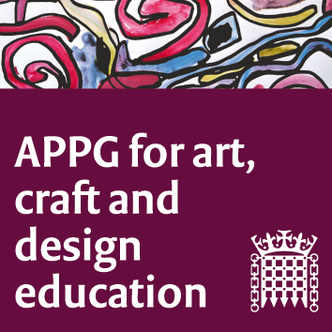

All-Party Parliamentary Group for Art, Craft and Design in Education
Wednesday 22nd February 2017; 4 – 5:30 pm, Committee Room 21
Agenda
- Welcome from Sharon Hodgson MP.
- Lesley Butterworth, (NSEAD) An introduction to the issues affecting recruitment and retention in ITE for art, craft and design; A summary of the NSEAD’s Special Interest Group for Initial Teacher Education.
- Sophie Cole, (Programme Leader PGCE Secondary Art, Craft and Design, Northumbria University) and two current Northumbria PGCE trainee teachers, on the challenges faced by our next generation of art teachers and their motivations for committing to ‘the best career in the world’.
- Dr. Peter Gregory (Canterbury Christ Church University) presents the provider point of view, talking about issues at art and design in the primary education phase.
- Dr. Rachel Payne (Oxford Brookes University) Dr Rachel Payne (Oxford Brookes University) on the role of partnership and community in ITE.
- Conclusions and areas of concern/next steps that will inform the NSEAD Special Interest Group for ITE.
7. AOB.
8. Date/time next meeting: May 10th 2017, 4:00-5:30 p.m.

