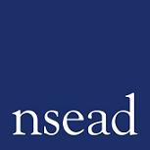

NSEAD COUNCIL ELECTIONS 2023-2025

COUNCIL NOMINATION FORM

From 1st January 2023 there will be 3 vacancies on the Society’s National Council. All Full Members, Associate Members and Honorary Members in good standing and resident in Great Britain and Northern Ireland are eligible to stand for election for a three-year term until December 31 2025.

We are particularly keen to receive nominations for members to represent the following phases/sectors:

Primary
Higher Education/Initial Teacher Education
Cultural sector

and from the following areas:

Scotland
North West
West Midlands

However, we will accept nominations from any phase, sector or area.

NSEAD Council should represent all of our members, and we are particularly keen to receive nominations that reflect the full diversity of our members. In addition, ne place on Council is reserved for an early career teacher and nominations from new entrants to the profession are warmly encouraged.

Any member who would like to put themselves forward should ask an NSEAD member to complete the PROPOSER section of this form, then complete section 2 and 3 and return to the General Secretary by email and post before the deadline. If there is more than one candidate for each vacancy, an election will be held amongst the NSEAD membership.

This nomination form, together with a brief biography/election address prepared by the nominee (min 100 words, max 150 words), must be emailed* to michelegregson@nsead.org
and a signed copy sent by post to the Society at NSEAD, 3 Mason’s Wharf, Corsham, Wilshire SN13 9FY no later than 12 noon on Friday 7 October 2022

Michele Gregson
General Secretary

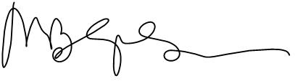

Nomination for Council 2023-2025

SECTION 1

To be completed by the PROPOSER (the NSEAD member supporting your nomination):

I wish to nominate

(Full name of member to be nominated) to serve as a member of Council for the term of office ending December 2024.

Full name of member making the nomination:

I confirm that I am a member of NSEAD.

Signature of member making the nomination:

Date:

SECTION 2

To be completed by the NOMINEE (the person standing for Council):

Vacancy applied for

I accept this nomination to serve as a member of Council: Yes/No

Full name of nominee

Signature of nominee:

Date:

SECTION 3

Election Address (100-150 words max) Please use this space to outline your experience and interest in joining NSEAD Council.

