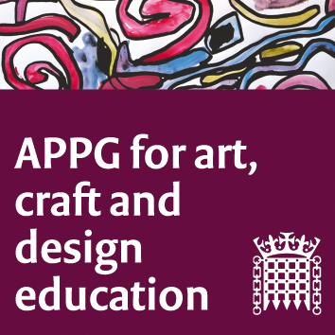

The All-Party Parliamentary Group for Art, Craft and Design in Education

An informal meeting (online) Tuesday June 2nd 2-4 pm

Minutes

Meeting focus/theme: Please note that this is an informal meeting. A decision was made to focus on discussion and sharing of how teaching and learning has had to change rapidly due to Coronavirus. We also looked at plans for the near and distant future, and a held a discussion on the vision for the direction of the APPG, post-pandemic (whenever that may be).
- Welcome. Sharon Hodgson MP.
- Zoom protocol reminders. Susan Coles, NSEAD.
- Summary of NSEAD's activities since 'lockdown' and plans for Conference etc. Michele Gregson reminded us all that the question about the future of education has been raised by the way teachers and their students have worked during lockdown. Teachers had bravely steeped up to the new landscape. NSEAD will continue to monitor developments in art education and support members throughout these times. The NSEAD 2020 Conference will be an online event and people were encouraged to sign up for the talks, presentations and discussions. A copy of the summary is available here; LINK
- Examination changes 2020, a summary from Liz MacFarlane, President elect, NSEAD. NSEAD have liased with OFQAL around the issue of GCSE and A level ‘exams’ in our subject and had responded in detail to consultation requests. Equality of opportunity for the subject is a major factor in these. A copy of the responses to the consultation can be seen here; LINK
- The teacher’s point of view: what lockdown has meant for them in primary, secondary and tertiary phases of education. Ruth Robinson Lead Teacher and Leader of Learning: Arts, English & Business at Durham 6th Form , Jessica Austin Burdett, Head of Art, Design and Technology at John Cass school in London. Ruth shared her department’s ways of working remotely and, in particular, through the use of the Google classroom platform, and talked about the need to support the well being of young people during a stressful time in their lives. She believes it is important to focus on the ‘highs’ as well as acknowledge the ‘lows’. Jessica concurred with this and talked about how the social divide between those with access to technology and those without (for home learning) had been tackled at her school, through distributing learning packs etc. Her team had seen the need to revisit their core purpose for art education, which was empowering for them all.
- Wellbeing issues, young people and art educators, around Covid 19. The NSEAD Special Interest Group on Wellbeing, Marlene Wylie Vice President NSEAD, Amanda Skilton (teacher) and Bradley Hodgson (teacher) shared their concerns for the wellbeing of both learners and teachers in the current lockdown and pandemic situation and how to recognise and be open about these. Amanda referred participants to the excellent work that had been done by the creators of the international Recovery Curriculum, by the Anna Freud Centre and the Young Minds websites, to support teachers and learners (and their parents). The SIG are working together to create supporting resources for key stakeholders in art education, to create signposts and add downloadable well-being resources to the website to support NSEAD members. There is an article appearing in the next AD Magazine and plans for a webinar focussed on the issues.
- Group discussion chaired by Sharon Hodgson. The future focus and work of the APPG, based on previous discussions held at the AGM in 2020, and the previous meeting in February was shared by Jack Mayorcas and Susan Coles. The idea is to use specific foci for evidence based sessions to produce summative reports which will help in lobbying for the subject in parliament and which will show more of an ‘outcome’ for the APPG.
- Next meeting- time and date and platform. An official (online)meeting of the APPG is planned for November. Date tbc.
- AOB.

