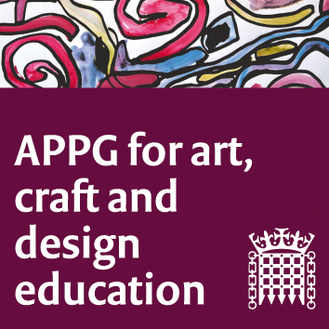

All Party Parliamentary Group Art, Craft and Design in Education

Wednesday 14th September 2016; 4 – 6pm, Committee Room 15
Agenda

Chair’s Welcome & Introductions.
- Minutes of Last Meeting/Actions Arising.
- Update from Henry Vann, Incorporated Society of Musicians, on Bacc for the Future campaign.
- Lesley Butterworth, General Secretary NSEAD and Sophie Leach, Assistant General Secretary NSEAD: next steps for the EBacc campaign; GCSE/GCE results; Traction on the NSEAD Survey Report 2016; Financial implications on the subject to include A&D and DT departments merging/being mothballed and the impact that has on our subject; Amplifying craft and design – including discussion.
- Julia Bennett: Head of Research and Policy Crafts Council, Studying Craft 16 - an update from the Crafts Council on trends in craft education and training since 2007/08. Including discussion.
- Kate Holland, Bookbinder (with Lord Sawyer): the national demise of bookbinding education within the wider context of the downturn of craft education.
- Sorell Hershberg, Director of The Sorrell Foundation: The Creative Journeys films, an encouragement to young people to consider careers using Art, Craft and Design.
- Susan Coles, NSEAD: updates on the joint APPG group summit on 11 October 2016.
- AOB.
- Date of next meeting.
  - 14th December 2016.

