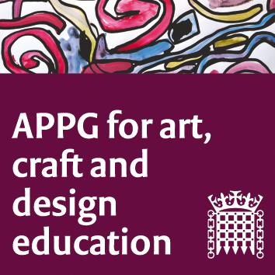

The All-Party Parliamentary Group for Art, Craft and Design in Education

Meeting online (Zoom platform) Tuesday 22nd June 2021. 5-7 pm

Agenda

Questions and discussion will take place between agenda items at the discretion of the chair.

Our main session focus is the sharing of current initiatives and campaigns around visual art education and the work of the APPG.

1. Sharon Hodgson MP and Chair, welcome. (Participants to use CHAT for introductions)

2. Minutes from last meeting to be approved.
3. The NSEAD Anti-Racist Art Education Action (ARAEA) Group was set up in 2020, following the murder of George Floyd. The Group have published three Anti-Racist Art Education Checklists that aim to support conversations around anti-racism, to help promote racial tolerance and equity. The ARAEA Group challenge all art educators to be actively anti-racist to ensure the injustices brought about through racism are removed. The ARAEA Group members presenting: Marlene Wylie (Vice-President NSEAD and Creative Education Consultant), Clare Stanhope (Head of Art & Design and Researcher), and Sophie Leach, (Deputy General Secretary NSEAD).

4. Kingston University has just produced a report with YouGov Business on UK skills priorities, which was officially launched this month. Based on interviews with major businesses including the likes of Deloitte, Mastercard and Lidl and a poll of 2,000 UK employers, the report reveals an urgent need to promote creative problem-solving skills to meet a threat to UK competitiveness from emerging economies. Steven Spier, Vice-Chancellor of Kingston University, will share the findings and potential policy implications. Link to report: https://tinyurl.com/ybnhyx3h

5. Sandra Booth CHEAD (Council for Higher Education in Art and Design) Director of Policy, who will update us about the campaign #ArtIsEssential. ‘The arts and culture sector contributes £2.8 billion a year to the Treasury via taxation to the UK economy, and provides 363,700 jobs, but recent events have exposed the delicate ecology of the sector leaving it vulnerable. We need to ensure that policy and decision makers are considering the real needs of our sector and sees the far reaching impact the visual arts has in our communities and the contribution it makes to our economy. This campaign has been set up to unite us as one voice. As a sector, we need to come together to be visible throughout 2021 and the run-up to the Government Comprehensive Spending Review to demonstrate that #ArtIsEssential’.

https://www.artisessential.art/about

Sharon Hodgson MP, APPG chair, letter to Gavin Williamson: https://www.nsead.org/files/843cd27bb615fe24c5abe39432f45519.pdf

5. Professor Samantha Broadhead (University of the Arts Leeds) and Professor Pat Thomson (University of Nottingham) will update on progress of the APPG research group, and future plans.

6. Professor Pat Thomson will present the work that she shared at the 2021 iJADE (International Journal of Art and Design Education) Conference. This work (with Liam Maloy) was a Rapid Evidence Review into the benefits of Art, Craft and Design (AC&D) education in schools. The review also addressed the nature, status and sustainability of AC&D education in the face of changes to the national curriculum, accountability measures, online learning and austerity.

7. NSEAD updates and current work and projects, Michele Gregson, General Secretary of NSEAD.

8. AOB and date of next meeting.

