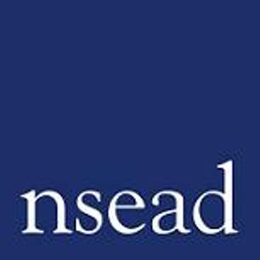
NSEAD Continuing Professional Development for Art, craft and design teachers
Name of teacher requesting CPD |  | (Teacher to complete)
Title of the Course: | Leading health and safety in the art classroom
Course Tutors: | Ged Gast – Art and Design education consultant
Focus of this course: | Is intended for secondary teachers, artist educators working in schools and anyone who is responsible for art and design activities, lecturers in further, higher and adult education, and those training to be teachers may also find it helpful. The webinar provides a complete guide to health and safety in the art classroom.
What will delegates learn? | - Why health and safety is specifically important in the art classroom  - How and where to access advice and guidance that covers all aspects of health and safety within the art classroom  - Understanding responsibility and assessing risks  - Practical guidance of how to take action, review and manage health and safety in the art classroom going forward
How will this develop professional practice for specialist art craft and design teachers? | - As with any practical activity, there is an element of risk in art and design activities. However, this can be kept to an acceptable minimum if those involved are aware of the potential hazards and take appropriate steps to avoid accidents. It is particularly important that teachers are aware of their responsibilities regarding health and safety and ensure that pupils act safely, within acceptable bounds, at all times.

For teachers to complete
How will my students benefit? | (may relate to: embed skills, knowledge and understanding, ‘cultural capital’, progress, achievement, motivation, aspiration, positive attitudes, community engagement, transferred skills)
How will my learning contribute to whole school improvement priorities? | (may relate to: Behaviour and attitudes, attendance, personal development, leadership and management, improving staff’s subject, pedagogical and pedagogical content knowledge; curriculum development, assessment, community engagement, workload and well-being, equity, diversion and inclusion,
Links to performance review and personal development goals

Cost | NSEAD member:  Non member:

