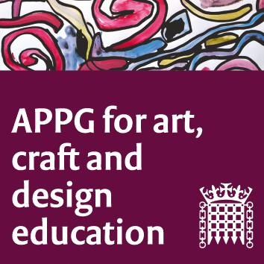

The All-Party Parliamentary Group for Art, Craft and Design in Education

Meeting online (Zoom platform) Tuesday 2nd March 2021. 5-7 pm

Agenda

Questions and discussion will take place between agenda items.

Our main session focus is the benefit of art education within both prison settings, and beyond in recovery/rehabilitation.

1. Sharon Hodgson MP and Chair, welcome (Participants to use CHAT for introductions) 5 mins

2. Minutes from last meeting to be approved. (attached)

3. Updates from around the UK, Art Craft Design education; Michele Gregson, General Secretary NSEAD. 10 mins

4. Unlock the Talent Inside; Sally Taylor CEO of Koestler Arts https://www.koestlerarts.org.uk/ will talk about the work that the organisation does promoting engagement with art in prisons and as part of prisoners rehabilitation. 20 mins

5. From the inside; Professor Samantha Broadhead (University of the Arts Leeds) will talk about her own experiences teaching art in prisons. 15 mins Writer Mim Skinner and author of the book ‘Jailbirds’ https://www.amazon.co.uk/dp/B07GYM1JNM/ref=dp-kindle-redirect?_encoding=UTF8&btkr=1 Mim taught therapeutic and self-expressive arts in one women's and two men's prisons. She used art, music, and writing to engage those at the edge of the prison system with the aim of connecting people into further education, training and rehabilitation. 15 mins

6. Ruth Williams, Watts Art Gallery, Surrey, will talk about their art education link and work, between the Watts Gallery Trust and prisoners and young offenders. https://www.wattsgallery.org.uk/learn/community-engagement-outreach/hmp-yoi-feltham/ 20 mins

7. Ten successful and influential years of the NSEAD AD Magazine: a whirlwind tour of the first decade of NSEAD’s flagship publication on visual art education. Sophie Leach, Deputy General Secretary of NSEAD. 10 mins

8. Brief report on progress of APPG Research group. Research group team. 5 mins

9. AOB and date of next meeting.

