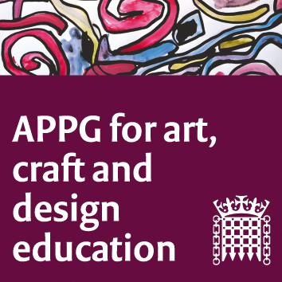

The All-Party Parliamentary Group Art, Craft and Design in Education
AGM: Wednesday 17 October 2018

Room 0, Portcullis House

4.00-5.00pm

Agenda:
1. Introductions
2. Election of Chair
3. Election of Vice-Chairs
4. Brief update on ‘Drawn Together’ group
5. NSEAD/APPG priorities for this academic year
6. Date of next meeting November 13th 4-6pm

