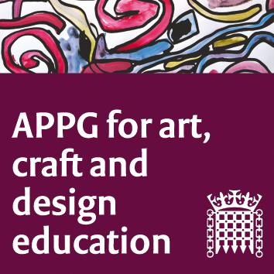

The All-Party Parliamentary Group for Art, Craft and Design in Education

Meeting online (Zoom platform)

Tuesday 24th November 5-7 pm

Agenda
- Welcome. Sharon Hodgson MP.
- Report from first APPG evidence session, quick summary and next steps. Jack Mayorcas and Susan Coles.
- Summary of NSEAD's activities since the last meeting in June. Michele Gregson, General Secretary.
- ITE Bursary Letter to Mr Gibb. Dr Rachel Payne, President of NSEAD.
- Trainee teachers, Lucy and Lee, from the University of Staffordshire PGCE Art and Design course, will talk about the importance of the 2020 bursary (which the Department for Education will not be continuing in 2021). Introduced by their course leader and member of NSEAD Council, Katie Leonard.
- Ben Cooper, author of the Fabian Report ‘Cultured Communities’ the crisis in funding for local communities in Arts and Culture will discuss key points from this.
- ‘Drawing for Learning in Anatomy, why visual and tactile literacy is important in the STEM subjects in Higher Education’. Dr Fay Penrose, Senior Lecturer in Veterinary Anatomy, University of Liverpool.
- Prof José Chambers, Development Fellow, Comino Foundation and supporter of the APPG, will introduce an established model of working in which digital design graduates from Manchester Metropolitan University undertake short internships with Greater Manchester schools, with cultural institutions as partners. We will meet Dr Melanie Miller, programme leader, and teachers and designers from two recent projects: Abraham Moss Community School - Manchester, with Manchester Art Gallery as cultural partner, Leonnie Burns- teacher; Rebecca Burns – designer. "Our Cheetham Hill community - a human rights perspective". Ladybridge High School, Bolton, with Manchester Science Industry Museum as cultural partner Joy Helliwell - teacher; Tom Cockerham – designer. "Bygone Bolton- a digital 3D design project."
- Date and time of next meeting.
- AOB.

