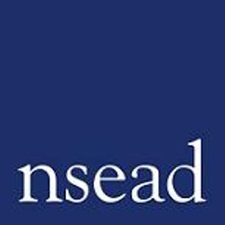
NSEAD Continuing Professional Development for Art, craft and design teachers
Name of teacher requesting CPD |  | (Teacher to complete)
Title of the Course: | Managing Behavior
Course Tutors: | Steve Rose – Art Education Consultant and Lecturer
Focus of this course: | Provides you with practical strategies and knowledge to develop your skills to feel confident managing a classroom
What will delegates learn? | Practical guidance on managing behaviour at all levels  - Strategies at school level  - Strategies at class level  - Strategies for you as the teacher  - Strategies and responses for children and young people
How will this develop professional practice for specialist art craft and design teachers? | - Developing specific strategies to managing behaviour within the art classroom at all levels.  - Understanding the importance of knowing your students and how to approach them to engage with the subject.  - Exploring behaviour policies and how they relate and work within the art classroom.

For teachers to complete
How will my students benefit? | (may relate to: embed skills, knowledge and understanding, ‘cultural capital’, progress, achievement, motivation, aspiration, positive attitudes, community engagement, transferred skills)
How will my learning contribute to whole school improvement priorities? | (may relate to: Behaviour and attitudes, attendance, personal development, leadership and management, improving staff’s subject, pedagogical and pedagogical content knowledge; curriculum development, assessment, community engagement, workload and well-being, equity, diversion and inclusion,
Links to performance review and personal development goals

Cost | NSEAD member:  Non member:

