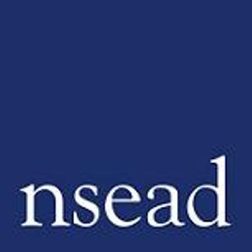
NSEAD Continuing Professional Development for Art, craft and design teachers
Name of teacher requesting CPD |  | (Teacher to complete)
Title of the Course: | Leading examination programmes in a post covid landscape
Course Tutors: | Ged Gast – Art and Design education consultant  Liz McFarlane - President of NSEAD and an Art and Design education consultant
Focus of this course: | provides practical support and knowledge for compliance with the regulations that govern our practice as teachers of a non-examination subject.
What will delegates learn? | - Overview of GCSE content  - What are the regulations? – review of the JCQ documentation  - What are the implications for teachers applying the regulations as students proceed through the course?  - Experienced subject leaders share their GCSE priorities and approaches  - Establishing good learning behaviours and habits  - Preparing for the externally set assignment  - Methodology – what skills do you plan to develop?  - How do you ensure students have knowledge, skills and practice?
How will this develop professional practice for specialist art craft and design teachers? | - Developing a better understanding of GCSE examinations in art & design  - Understanding the expectations of senior leadership  - Exploring the documentation, regulations and prohibited actions when teaching and preparing students for examination and marking  - Addressing what is best practice and how should you plan your KS3 and 4 curriculum to ensure you are GCSE ready.

For teachers to complete
How will my students benefit? | (may relate to: embed skills, knowledge and understanding, ‘cultural capital’, progress, achievement, motivation, aspiration, positive attitudes, community engagement, transferred skills)
How will my learning contribute to whole school improvement priorities? | (may relate to: Behaviour and attitudes, attendance, personal development, leadership and management, improving staff’s subject, pedagogical and pedagogical content knowledge; curriculum development, assessment, community engagement, workload and well-being, equity, diversion and inclusion,
Links to performance review and personal development goals

Cost | NSEAD member:  Non member:

