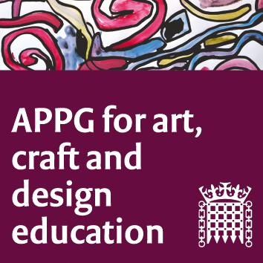

The All Party Parliamentary Group for Art, Craft and Design in Education

Tuesday 25th February 2020, Committee Room 5.

5-7 p.m.

House of Commons

Agenda

Meeting focus/theme: The achievements, impact and purpose of the APPG since its first meeting in March 2013 and open discussion on both short and long term plans for future work.

1. Welcome from Chair, Sharon Hodgson MP, and introductions.
2. Report from the ‘plan B’ meeting held at Chelsea College of Art on November 12th 2019, during Parliamentary purdah. NSEAD team.
3. Seven years of the APPG: how it all began and why. Sharon Hodgson and Susan Coles. Followed by a summary of some of the campaigns and successes, Michele Gregson NSEAD.
4. How the APPG meeting in May 2018 influenced the INSPIRE project at the Fitzwilliam Museum, Cambridge. Kate Noble, Education Officer at the Museum, Sheila Ceccarelli, co-director AccessArt.
5. Report from the 22nd January AGM. Sharon Hodgson and Jack Mayorcas to outline suggestions made by the newly elected Parliamentary officers of this group, for future work and focus. Michelle Gregson (General Secretary NSEAD) to share the NSEAD 2019 Manifesto headings. Whole group discussion to follow.
6. The impact of the recent parliamentary vote on the Erasmus scheme. https://www.bbc.co.uk/news/education-47293927
(Erasmus+ is an EU scheme that currently offers opportunities for UK citizens to study, work, volunteer, teach and train abroad in Europe and offers access to funding for adult education). Earl Clancarty.

7. AOB. Date and time of next meeting: Tuesday June 2nd 2020, 5-7 pm CR 15.

