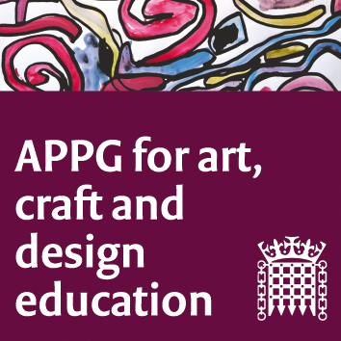

All Party Parliamentary Group Art, Craft and Design Education
Tuesday 12th Jul 2016
Room N in Portcullis House
3 – 3.30pm

Agenda:
1. Introductions.
2. Election of Chair
3. Election of Vice-Chairs
4. AOB
6. Date of next meeting
- Wednesday 14th September, 4 – 6pm

