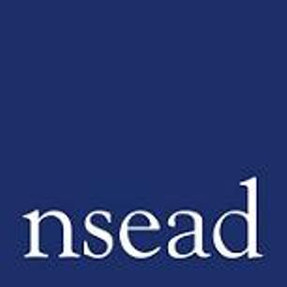

The National Art and Design Education Conference
Leading better practice for art, craft and design educators across the UK

2026 Conference: Creative Curriculums: Care, risk and courage
Name of teacher requesting CPD: | (Teacher to complete)
Focus of this conference: | NSEAD’s Annual Conference brings together art educators from across the UK, from all phases and sectors engaged in art, craft and design education. A key event in your calendar, the conference is your opportunity to keep up to date with the latest developments for our subject, connect with others and exchange ideas.
What will attendees learn? | Creative bravery is central to art, craft and design education. As teachers of art, craft and design we navigate risky territories of practice. We encourage our learners to take creative risks, experiment, think critically, face challenging issues and be comfortable with uncertainty. How do we ensure that we are able to nurture creative courage, whilst maintaining our classrooms and studios as safe spaces for us and our learners? And we ask, how might our subject help us preserve our health and well-being in the face of societal and global challenges.  This conference invites us to consider creative, personal and professional risks that we encounter in our practice as educators, and the ways that we can navigate them with care and confidence.  The programme combines inspiring presentations with the latest research and information to help you and your learners. Workshop sessions will provide an active space for you to develop your own professional practice, with learning that you will take directly back to the classroom and studio.
How will this develop professional practice for specialist art, craft and design teachers? | - Explore the conditions that foster safe learning environments  - Discover practical steps that foster creative curricular  - Tools for navigating complex, sensitive or challenging themes with confidence and care  - Connection with a community of educators committed to thoughtful, courageous practice  - Stay updated on curriculum developments  - Be inspired, refreshed, enthused  - Ask questions, get the answers you need  - Lead our subject with confidence

For teachers to complete
How will my students benefit? | (May relate to: Embedding skills, knowledge and understanding; progress and achievement; motivation; aspiration, positive attitudes; community engagement; transferrable skills)
How will my learning contribute to whole school improvement priorities? | (May relate to: Behaviour and attitudes, attendance, personal development, leadership and management, improving staff’s subject, pedagogical and pedagogical content knowledge; curriculum development, assessment, community engagement, workload and well-being, equity, diversion and inclusion)
Links to performance review and personal development goals:

Cost: | NSEAD member:  Registration fee only: £10  The annual conference is a key member CPD benefit, included in your subscription: members are only required to pay a nominal registration fee of £10 for the conference, and receive discounted rates for the summer gathering.  Non-member:  Early Bird Registration fee: £125.00 (until 20 April 2026)  Standard fee: £145.00  Not a member? Join now to access the conference at our member’s rate, plus a whole year of CPD, resources, research, support, community and more. Annual membership fees start from just £56.70*  * For part time and ECT Professional Associates. T&Cs apply.

