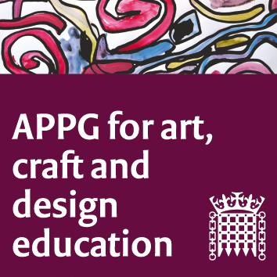

The All-Party Parliamentary Group for Art, Craft and Design in Education

Tuesday 12th February 3-5pm

Room C, 1 Parliament Street SW1A 2BQ

1. Welcome from Chair, Sharon Hodgson MP, and introductions: Minutes of the last meeting to be shared and approved. 5 mins
2. NSEAD update and future plans: Michele Gregson and Sophie Leach NSEAD. 10 mins total
3. A challenge to remarks recently made by HM Chief Inspector of Education, Children’s Services and Skills regarding a mismatch in arts and media courses and career options. Eleanor Simms, Clare Bentham, The Outreach Team at Manchester School of Art present. 15mins total

4. Cross-sector (HE, FE and schools as well as other agencies) collaborations with regard to fine art education: Cross-sector (HE, FE and schools as well as other agencies) collaborations with regard to fine art education: Chris Smith, National Association for Fine Art Education (NAFAE). 20 mins total

5. Art+Maths=Fergal: Meet Fergal Voorsanger-Brill, cited by his dad Bob and Roberta Smith, in a recent debate on Radio 4's Front Row, as an example of how a creative imagination is a prerequisite for young people keen to enter careers in design. The presentation will include first-hand experience and perspectives on what is needed to be successful in design education. 15 mins total
6. The limitations of Longitudinal Employment Outcomes (LEO) research and data: Gordon McKenzie CEO of GuildHE will summarise the report Understanding the limitations of graduate outcome measures in higher education and identify the significant issues for high education should LEO data be the only measure of graduate success in the labour market. Read the report here: https://guildhe.ac.uk/new-research-highlights-limitations-of-leo-data/ 20 mins total

7. Why do mature students in art and design matter? Martell Baines, Progression Manager and Dr Sam Broadhead Head of Research, Leeds Arts University. 20 mins total
8. AOB
9. Date and time of next meeting: Tuesday 14 May, 5-7pm.

