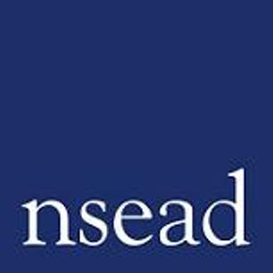
NSEAD Continuing Professional Development for Art, craft and design teachers
Name of teacher requesting CPD | (teacher to complete)
Title of the session: | Leading through practice: from Visability to ‘Thisability’
Speakers: | Saranjit Birdi | artist
Focus of this session: | Art practice inspired by movement and the body, challenging misconceptions about who can be an artist.
What will delegates learn? | Challenging different ideas of ‘ability’ and ‘able’. New thinking about inclusion, practical ideas to translate to the classroom.
How will this develop professional practice for specialist art craft and design teachers? | Opportunity to engage with NSEAD Research group for Advancing Anti-ableist pedagogies

For teachers to complete
How will my students benefit? | (may relate to: developing ‘cultural capital’, improving motivation, aspiration, positive attitudes, mental health and well being, skills development, social and community engagement, transferred skills)
How will my learning contribute to whole school improvement priorities? | (may relate to: developing positive behaviour and attitudes, personal development, curriculum development, community engagement, equity, diversity and inclusion)
Links to performance review and personal development goals

Cost | NSEAD members: £5  Non members: £15  FREE with Conference pass

