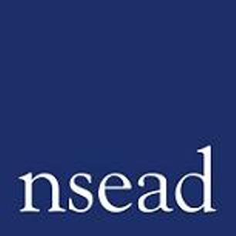

NSEAD Equal Opportunities Monitoring Form

Why are we collecting this information?
NSEAD is committed to Equal Opportunities and aims to provide a working and training environment free from unfair discrimination that will enable employees, participants, volunteers and members to fulfil their potential. NSEAD ensures that no individual is discriminated against because of their age, disability, gender identity, marital status, race, religion or belief, sexual identity, family circumstance, socio-economic background or status or other distinction. By providing this information, you will help us to understand the proportion of applicants from candidates with protected characteristics under the Equalities Act 2010.
How will we use this information?
NSEAD have a commitment to non-discrimination and where necessary, positive action to improve equality and diversity in our organisation. Shortlisting is undertaken on a 'blind' basis. This means that the candidate’s personal details (e.g. name, address, age, etc.) are not visible to the shortlisting panel. Candidates will be referenced by candidate number and initials only.
The information you provide is strictly confidential and removed from your application prior to consideration for shortlisting and interview.
Once the shortlisting exercise has been completed, the candidate’s name and contact details will be shared with the interview panel. In the event of a ‘tie breaker’ where two or more candidates are of equal merit, the interview panel will take into consideration whether one is from a group that is disproportionately under-represented or otherwise disadvantaged within art, craft and design education and in the creative industries.
The information is not used or disclosed in consideration for salary progression, promotion, or training and development..
Data Protection Act 2018
The information is requested to enable NSEAD to monitor its recruitment advertising and meet statutory obligations. The form is held for up to 6 months whilst the data is anonymised and then destroyed.
.

Please complete in block capitals and highlight those which most closely relate to you:

Position applying for:
Date:

Sex: I would describe my gender as:

Age: 0-19 20-34 35-49 50-64 65+

Nationality:

Ethnic Origin:
ASIAN OR ASIAN BRITISH | BLACK OR BLACK BRITISH | CHINESE OR OTHER ETHNIC GROUP | MIXED | WHITE
Indian | Caribbean | Chinese | White & Black  Caribbean | British
Pakistani | African | Any other | White & Black  African | Irish
Bangladeshi | Other black  background |  | White & Asian | Other white  background
Other Asian background |  |  | Other mixed  background

Disability:

NSEAD welcomes applications from people with disabilities and aims to be supportive in their employment. We will be pleased to consider any special requirements, reasonable resources or facilities that will support you when applying to or working for the organisation.

Do you consider yourself to have a disability? Yes No

A person has a disability if:
a) they have a physical or mental impairment, and
b) the impairment has a substantial and long-term adverse effect on that person’s ability to carry out normal day-to-day activities

Do you have any specific individual or access requirements?

No Yes

If ‘Yes’ please give any relevant details:

NSEAD USE ONLY: APPLICATION NO:

