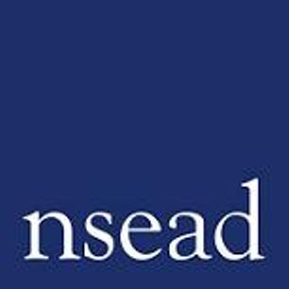
NSEAD Continuing Professional Development for Art, craft and design teachers
Name of teacher requesting CPD | (teacher to complete)
Title of the session: | Leading Change in Uncertain times: art as activism  25 May 2022
Speakers: | Bob and Roberta Smith| Artist, activist, NSEAD Patron  Caro Howell| Director of the Foundling Museum  Lily Pfafenzeller | Articulate Finalist
Focus of this session: | The role of educators, museums and galleries play to inspire and support young people to find, and raise their voice.
What will delegates learn? | Reflection and learning on the role that educators play to support and promote civic society – within schools, within galleries and museums and the potential for positive social change.  Information and action to engage students with the National Gallery Articulate programme,  Information and action to engage students, families and schools with the ‘Help Art Save lives’ campaign and the work of the Foundling Museum.
How will this develop professional practice for specialist art craft and design teachers? | About programmes and resources that galleries provide that can be part of curriculum planning.  How to introduce ideas and work that create a positive environment for learning

For teachers to complete
How will my students benefit? | (may relate to: developing ‘cultural capital’, improving motivation, aspiration, positive attitudes, social and community engagement, transferred skills, fundraising, debating, public speaking, critical analysis of artworks)
How will my learning contribute to whole school improvement priorities? | (may relate to: developing positive behaviour and attitudes, personal development, curriculum development, community engagement, equity, diversity and inclusion)
Links to performance review and personal development goals

Cost | NSEAD members: £5  Non members: £15  FREE with Conference pass

