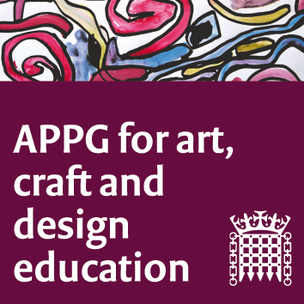

All-Party Parliamentary Group for Art, Craft and Design in Education
Tuesday 10th October; 4 – 5:30 pm, Committee Room 6
Agenda

- Welcome from Sharon Hodgson MP (chair).
- Letter to Justine Greening, Secretary of State for Education, re. Initial Teacher Education in Art, Craft, and Design. Sharon Hodgson MP.
- NSEAD updates and reflections on the past few months, including priorities and a review of summer 2017 examination entries for Art and Design. Lesley Butterworth and Sophie Leach, NSEAD.
- Bacc for the Future Campaign, updates. Henry Vann, Head of External Affairs, Incorporated Society of Musicians (ISM).
- House of Lords debate, on the impact of the English Baccalaureate on the take up of creative and technical subjects, and the case for broadening the curriculum, summing up and comments. Earl Clancarty (vice chair).
- Norwich UA Report ‘A review of Art and Design Education in Norfolk’s secondary sector’ headlines and summary points. Hilary Gresty, independent visual arts professional.
- The Heritage Crafts Association (HCA)) update: ‘The Radcliffe Red List of Endangered Crafts’ and ‘ Heritage craft apprenticeships, vocational and other career paths into heritage craft industries. Patricia Lovett MBE and Greta Bertram (HCA).
- AOB.
9. Date/time next meeting.

