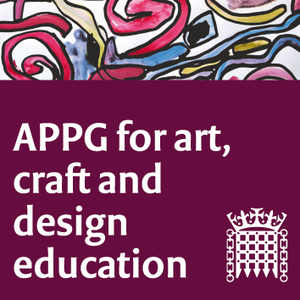

All-Party Parliamentary Group for Art, Craft and Design in Education
Wednesday 14th March 2018; 4-6:00pm, Committee Room 5
Agenda
- Chair’s welcome and introductions. Sharon Hodgson MP.
- Turner Contemporary, Margate, Kent. Karen Eslea (Head of Learning and Visitor Experience at Turner Contemporary) and Michele Gregson (Arts Education Specialist) have been working together to explore and champion Children’s Leadership through the Arts.
- Gomersal Primary School Art Council. Six students from the school are attending with their teacher Mandy Barrett and their headteacher Melanie Cox. The student “Art Council” will share with the group what their remit is and why they are here today.
- Branwen Jeffries (BBC Education reporter) will present conclusions from the recent BBC survey on the decline of Arts in the school curriculum. www.bbc.co.uk/news/education-42862996
- Andrew Baiseley of the National Education Union, will present an update on national school funding issues.
- Updates from NSEAD, including Sharon Hodgson’s letter to Damian Hinds. Sophie Leach, Assistant General Secretary NSEAD.
- Drawn Together joint APPG action, updates. Susan Coles.
- AOB
9. Date/time next meeting: Wednesday 16th May 2018, 4-6pm.

