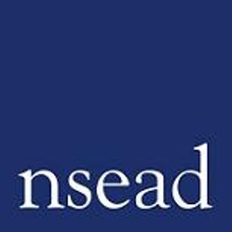
NSEAD Continuing Professional Development for Art, craft and design teachers
Name of teacher requesting CPD |  | (teacher to complete)
Title of the Course: | Leading cultural capital and equity in art education
Course Tutors: | Emily Gopaul – Artist and Art Education Consultant
Focus of this course: | This CPD session for Primary School Art and Design Subject leaders will build on ideas of how to approach Cultural Capital and Equity in the classroom
What will delegates learn? | This course will help you to learn ways of developing schemes of work and/or refining your existing provision in:  - Challenging the status quo of art content in primary settings  - Foster a genuine appreciation of diversity in your school  - Provide opportunities for children to celebrate their own cultural backgrounds  - Offer engagement with the rich cultural resources available, relating to other art and artists
How will this develop professional practice for specialist art craft and design teachers? | Teachers will:  - Be confident to plan coherent, relevant curriculum for all learners  - Develop their subject knowledge  - Develop pedagogical approaches and strategies to introduce and develop art and design knowledge, skills and practice  - Know how to create a positive environment for learning,  - Take away resources for the classroom

For teachers to complete
How will my students benefit? | Teacher to complete: (may relate to: ‘cultural capital’, progress, achievement, motivation, aspiration, positive attitudes, community engagement)
How will my learning contribute to whole school improvement priorities? | Teacher to complete: (may relate to: Behaviour and attitudes, attendance, personal development, improving staff’s subject, pedagogical and pedagogical content knowledge; curriculum development, community engagement, equity, diversion and inclusion)
Links to performance review and personal development goals

Cost | NSEAD member:  Non member:  With conference pass:

