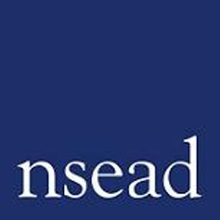
NSEAD Continuing Professional Development for Art, craft and design teachers
Name of teacher requesting CPD |  | (teacher to complete)
Title of the Course: | Leading Primary Art and Design
Course Tutors: | Susan Ogier - Primary Art and Early Years specialist
Focus of this course: | For primary subject leaders who are looking to develop this curriculum area in their schools.
What will delegates learn? | This course will support participants by offering both practical experiences, based upon pedagogical principles, and will help to develop creative confidence in providing children with opportunities for experimenting and exploring with art materials. Subject leaders will learn how to work with staff to ensure they are fully equipped to provide a high-quality art curriculum, as well as to create a vibrant and creative learning environment for children. The course will provide an opportunity to reflect and begin to develop an action plan that can be implemented in their schools.
How will this develop professional practice for specialist art craft and design teachers? | The course will offer strategies for building the foundations for developing confidence, enthusiasm and key knowledge in this subject, as well as an understanding of how to plan for progression across the primary years.

For teachers to complete
How will my students benefit? | (may relate to: embed skills, knowledge and understanding, ‘cultural capital’, progress, achievement, motivation, aspiration, positive attitudes, community engagement, transferred skills)
How will my learning contribute to whole school improvement priorities? | (may relate to: Behaviour and attitudes, attendance, personal development, leadership and management, improving staff’s subject, pedagogical and pedagogical content knowledge; curriculum development, assessment, community engagement, workload and well-being, equity, diversion and inclusion,
Links to performance review and personal development goals

Cost | NSEAD member:  Non member:

