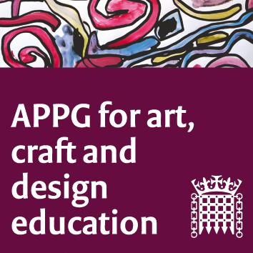

All-Party Parliamentary Group for Art, Craft and Design in Education

Tuesday 13th November 2018 3.45-5.45pm, Committee Room 14

Houses of Parliament

1. Welcome from Chair, Sharon Hodgson MP, and introductions. Minutes of last meeting to be shared.
2. Proposed changes to the Ofsted inspection framework, a summary and implications for art, craft and design in education, Sophie Leach, and Susan Coles, NSEAD.
3. ‘What are schools for?’ Carolyn Roberts, Head teacher, Thomas Tallis School, London. How and why Thomas Tallis School creates time for the broad and balanced curriculum.
4. Be a Creative Producer: Teenagers from Cambridgeshire will share their work. Year 9 teenagers (ages 12-13) are currently working on a series of animations aimed at encouraging peers across the country to become more aware of how they ‘consume’ the digital world, and how they can take the first steps to becoming creative contributors.
5. Misrepresentation of art and design and inequalities in current teacher recruitment policies, Rachel Payne, President-Elect, NSEAD. With reference to the letter sent to Damian Hinds MP, (23 October 2018) from the NSEAD Special Interest Group for Initial Teacher Education in Art, Craft and Design.
6. NSEAD: General Secretary update, Sophie Leach, Assistant General Secretary and Michele Gregson, General Secretary Elect, NSEAD.
7. Date and time of next meeting: Tuesday 12 February 2019, 4-6pm

