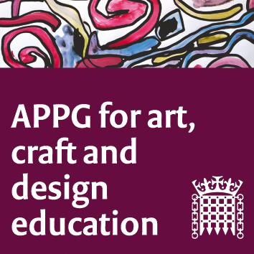

The All-Party Parliamentary Group for Art, Craft and Design in Education
Annual General Meeting – Wednesday 22nd January 2020 from 4pm – 4.30pm in Room U, Portcullis House

Minutes

- Sharon Hodgson MP opened the meeting, welcome everyone and listed the apologies given (these are listed below).

- The election of officers was agreed as below:

  - Sharon Hodgson MP – Chair
  - Gillian Keegan Conservative – Vice-Chair
  - Baroness Nye Labour – Vice-Chair
  - Baroness Jones of Whitchurch Labour – Vice-Chair
  - The Earl of Clancarty Crossbench – Vice-Chair
  - Lord Cormack - Vice-Chair

- It was agreed that Susan Coles will continue to provide secretariat services to the group, on behalf of NSEAD National Society for Education in Art and Design..

- Sharon provided details of the first meeting:

  - The first meeting of the year will take place on Tuesday the 25th February 2020 from 5pm to 7pm in Committee Room 5.

  - As it is a new Parliament the first meeting will set out the intentions and aims of the APPG.

  - Sharon and Susan Coles to discuss how and why the group came about in 2013. This will include and overview of the campaigns and successes, the children’s voices that have been heard, the relationships with the Department for Education and various Secretaries of State for Education.

  - Earl of Clancarty will be asked to talk about the lack of government support for the Erasmus Higher Education programme after Brexit.

  - The APPG also Influenced a great project in Cambridge - we are asking Kate Noble and Access Art to present some of the work they have been doing in Cambridge that was inspired by an APPG meeting in 2018 on the importance of CPD.

  - The meeting will also include more discussion about how we can make the APPG more influential and use the 2019 NSEAD Manifesto (written for the election) to guide the work.

  - Baroness Nye suggested that the APPG put together a report over the coming year bringing together all the work the group has been doing.

  - It was noted that a Class Ceiling report will be coming out soon.

  - It was suggested that a report by the group could be based on a series of evidence sessions or meetings.

  - The Early of Clancarty supported the idea of a report as it would be a good way of the group enacting change.

  - Rumours that the Department of Culture, Media and Support may be closed down were discussed and concerns raised as to what this would mean for the arts.

  - It was suggested that perhaps the Drawn Together group of APPGs could be brought back together.

  - The four categories for meetings / round tables contributing to the report could be: Children, Parents, Teachers and Researchers/Academics.

  - It was suggested that some officials from the Department of Education could be invited.

  - Baroness Nye suggested to broaden the contributions there could also be digital submissions form groups such as Mumsnet.

- Jack Mayorcas agreed to update Susan on the discussions above and move the work forward for the group.

The All-Party Parliamentary Group for Art, Craft and Design in Education
Annual General Meeting – Wednesday 22nd January 2020 from 4pm – 4.30pm in Room U, Portcullis House

Confirmed Attendees

- Sharon Hodgson MP (Lab)
- Earl of Clancarty (Crossbench)
- Baroness Nye (Lab)
- Tulip Siddiq MP (Lab)
- Chris Bryant MP
- Darren Jones MP
- Jack Mayorcas (Office of Sharon Hodgson MP)

Officers standing for election:

- Sharon Hodgson MP – Chair
- Gillian Keegan Conservative – Vice-Chair
- Baroness Nye Labour – Vice-Chair
- Baroness Jones of Whitchurch Labour – Vice-Chair
- The Earl of Clancarty Crossbench – Vice-Chair
- Lord Cormack - Vice-Chair

Apologies

- Baroness Jones of Whitchurch (Lab)
- Gillian Keegan MP (Con)
- Jane Hunt MP (Con)
- Lord Cormack (Con)
- Neil Coyle MP (Lab)
- Tracy Brabin MP (Lab)

